Suggested changes:
- 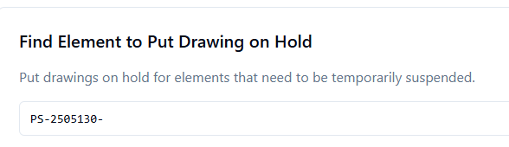
Title to be changed to ‘Find element to HOLD”

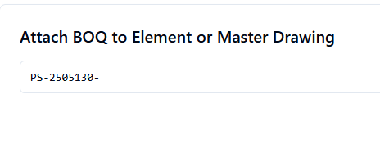
- Need to create separate Boq entry format for Master drawings

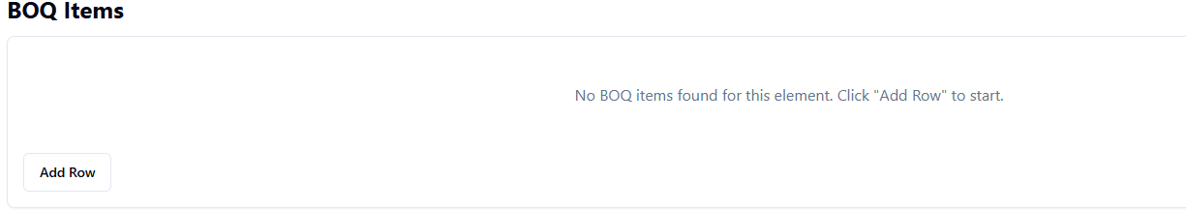
- First row should appear to enter BOQ. Add Row will be for the second row onwards

- For every section we should add “Reports”. Standard reports will be added to this in later stage

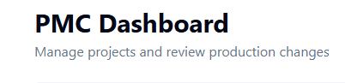
- PMC tag line ‘Manage projects – Control, coordinate, communicate, Cooperate..’

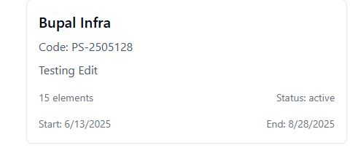
- In PMC dash board in place of 15 elements the format should be

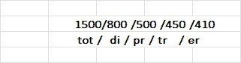

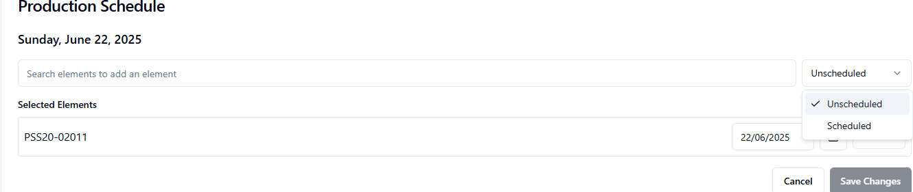
- In the search element bar unscheduled, scheduled only showing Deviations not showing
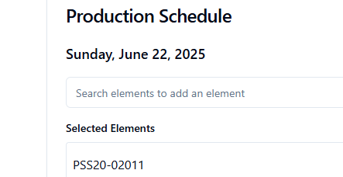
- in place of selected elements heading should be ’Scheduled Elements’

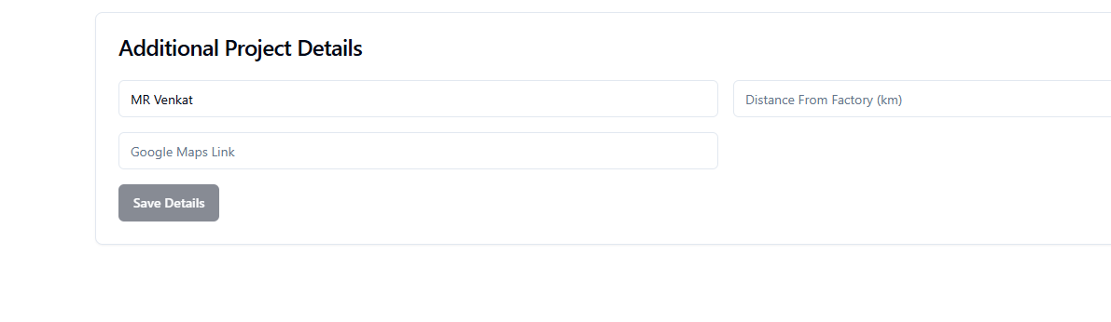
- This was not changed as discussed
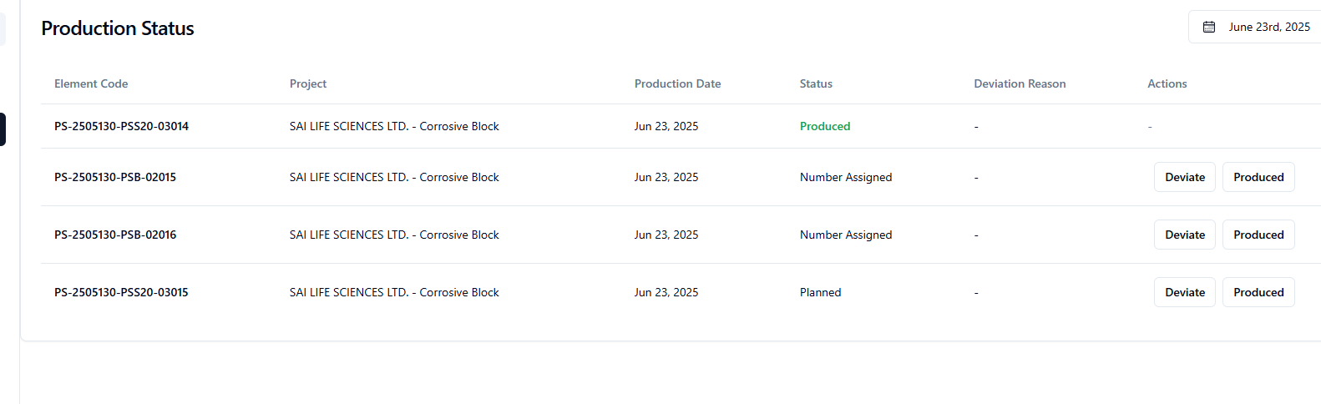
- in the status for some of the elements it is coming as number assigned, which is wrong. It should be planned

- In case element is waiting for ‘pending approval of PMC, same color code should be maintained both at PMC and operations department (Production, dispatch, erection)

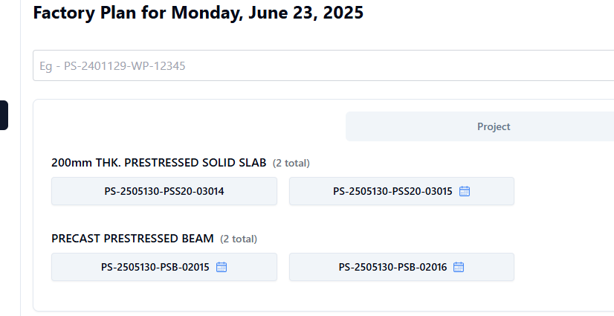
- Individual element wise total is coming but the day total is missing at the end of the day heading. Same should be checked in all the places of similar type

- In PMC dashboard under the ‘Status’ only production status was given. It should have all the status by selecting drop down like PMC => Planning, where we can select from drop down Production or dispatch or erection.

